# For Interns

## First Things First:

* 1. It is highly encouraged to have your updated **profile** **picture on slack, gmail** and any other platforms which will be used (now and in future, including HRMS).  
     (*Exception for females)*
  2. **Own** the responsibility of **your internship,** as any problems in your **internship** will affect you the most.
  3. WDs or Working Days are days that you work on. We track your progress by comparing your progress (as per our training timeline) with the number of working days.
  4. You are assigned **buddies as a contact point**, they are NOT supposed to monitor you all the time, if you are having any trouble understanding anything, you are supposed to work it out on your own, buddies will only help if you are totally unable to find a solution to your problems.
  5. **Own** the responsibility of **your training,** as any problems in your training will affect you the most. Thus, responsibly undergo the training process. **For ANY kind of issue**, we contact your buddy or training department timely. For general queries you can use relevant slack channels as well.
  6. **For any discussion you may need to have with the Training team; you need to make a group** (not a channel) **on slack which consists of the following:** [Training Coordinator](mailto:training.coordinator@devsinc.com)**, Your Buddy & Yourself.** [Training Coordinator](mailto:training.coordinator@devsinc.com) **Is a slack account that everyone in the Training team has access to**. However, if you feel like you need to discuss something with a specific person from the Training team, you may DM that person directly.
  7. Please note that it is **mandatory** for all trainees to be seated on the **same floor** as the buddy (permanent sitting), for maximum collaboration. (Girls can sit on that floor or their reserved floor, in either case, buddy should be in sync).
  8. If you are working remotely (with approval from the Training team) there are basic expectations that we have form you. Mainly connected with communication. Stable internet connectivity and availability over google meet/slack etc during working hours is mandatory to avoid disruptions and ineffective workflow. You can go over the work from home SOPs to get a basic understanding.

## Discussing Issues:

* 1. As an engineer you are expected to always first **search and explore** on your own to find answers, but don’t waste a lot of time in this step if you are not sure which websites to look for when searching in specific domains, or you are not finding anything useful in your own searching, get guidance from your buddy on how to better search online for certain domains(JS/Ruby/HTML etc).

**REMEMBER:** You are supposed to finish the training in a pre-defined time frame. So whenever you feel like you’re not getting anywhere, reach out to your buddy or use other channels as we will mention below.

* 1. When asking anyone anything, it’s best to **formalize your questions** in writing. This will build your communication skills(which are VERY important). It’s not required to always write queries, but highly encouraged.
  2. **#internship_collboration** is a slack channel(join this) which will be used for general day to day communications and other inter trainees chit chat, ie, for any basic queries which you think your fellow trainees can help clear out. Or for sharing knowledge/articles etc(which is highly encouraged).
  3. **#b#-interns** is a slack channel dedicated for batch discussions, collaboration with training team etc. You are also to send your daily standups here as well.
  4. **#dev_general** is a slack channel which you can use for more advanced/general queries or if you are having any problem understanding anything from training material. You are expected to write your queries in a formal and concise way, this will greatly help you with **your written communication skills**.  
     (Use this option if buddy recommends this for a given subject. It should come after you have tried **#internship_collboration** channel though.)  
     **PS:** There are all engineers of the company in **#dev_general**, so use it with responsibility.
  5. You are highly encouraged to always lay out your questions in writing. This will help you build soft skills along your technical skills, which is very important for your professional growth.

## Code quality and conventions:

* 1. Code you write, should follow best practices and conventions. Should be understandable, extensible, scalable and flexible(as much as possible).
  2. Understand and follow **single responsibility** and **separation of concerns**, among other general best practices.
  3. Properly configure linting tools for whatever technology you start work on, so you can fix most of the code problems around consistency etc timely.
  4. For ruby, configure **rubocop** and rubocop linting(as per your IDE). A recommended rubocop config file(.rubocop) is shared: [*recommended config*](https://gist.github.com/ziaulrehman40/8cf573331b14d10b0a88b1221956f1a9)
  5. If/when you train on any JS framework, **ESlint** should be properly configured with some boilerplate configuration, like <https://github.com/standard/standard> (configure it as per your frontend stack/framework at the time).
  6. **Point of linting tools** is to enforce consistency more than any specific standards, so it's totally fine if you opt to use any specific conventions, as long as they are consistent, logical, and configured properly in the linting tools.

## Professionalism:

* 1. [Here](https://docs.google.com/document/d/1ufbImB40Gp8aZLs5wuo1fnkeIcymKC1vkA2-fztAnBw/edit?usp=sharing) are some general instructions.
  2. As discussed in orientation by the HR department, you have **40 hrs/week**, follow this and make sure you are properly using your time tracking meter.
  3. All things mentioned here and otherwise general professional attitude will be monitored and eventually count big in your final evaluation at the end of the training.   
     And after training, these habits will lead you to progress better in your career. :)

## Scrums / Standups:

* 1. When starting work day, please send a message in #**b#-interns** (signing in), so buddy and the training department know you have started work. (This is irrespective of if you are working remotely or from the office)
  2. You are supposed to send your **daily standup** in an email (same thread, don’t create new threads daily). This should be sent **before day end**.  
     **Create a thread with subject:** Intern Standup - Intern - NAME  
     **To**: Buddy, **CC**: Training([trainings@devsinc.com](mailto:trainings@devsinc.com) )  
     **NOTE**: Always **“reply all”** in this thread for each standup.
     1. Recommended standup format is below(suggestions always welcome):
     2. **Learning to format your messages in slack + email is also part of training**, that’s why only a screenshot of standup format is shared above. Produce the same formatting on both email and slack, you can reuse the template once generated with the formatting. But you should try to generate the template yourself at-least once so you can get comfortable with the formatting on slack + email.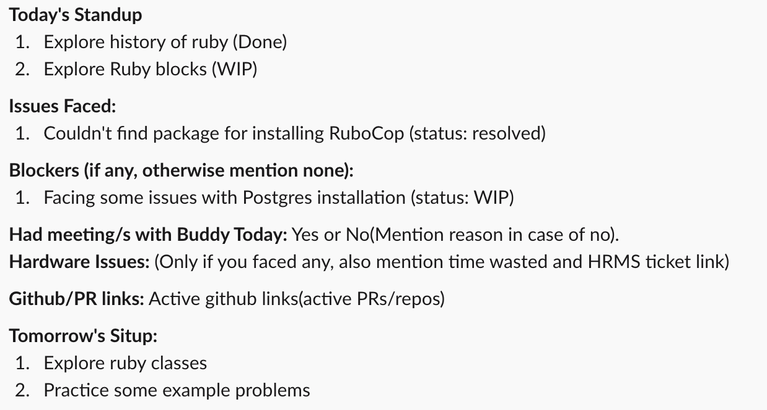
     3. Standups should be concise and to the point, and items should be grouped as well. But should not miss important details either.
  3. Training department will have **weekly syncs with all internees in groups**. Invites of these will be sent to you.

## Test project:

* 1. Test project is started once you have completed general training of the language and framework.
  2. Please make a **github account** with your company email.
  3. Make a **private repo** in your account, before starting the test project.
  4. Give access to this repo to your buddy(ask him his github username) and training department rep **(devsinc-training-coordinator)**.
  5. Before actually starting work, [get yourself familiar with git](https://rogerdudler.github.io/git-guide/) (or use [this link](https://www.notion.so/Introduction-to-Git-ac396a0697704709a12b6a0e545db049)).
  6. More instructions around the test project are detailed [here](https://docs.google.com/document/d/1kseQABmer0sSCUVsoZLuWvApkzAkOh2kos_QbSeyRJM/edit), these will be used when you reach this step.

## Miscellaneous:

* 1. If **any issues are found in the training documents**, please report it to your buddy and training department.
  2. In general, **any issues you face**, should be brought up with your lead(which is the trainer/buddy during training) then to the manager, timely.
  3. **At the end of internship, you will get a thorough review of your training and test project, there can be a viva or an assignment as well**. As this internship is leading to a job, job offers will be extended to top performers.
  4. **All the remarks from your evaluations will be recorded and monitored**. be it Ruby/Rails/Test Project, anything.
  5. Good luck, have fun, happy learning!

# For Buddies

1. You are assigned as a buddy to help internees. Take it as is, but it should not in any way affect your efficiency on your assigned project/s.
2. You cannot overrule(or ignore) any of the SOPs without talking to the training department formally.
3. **Try to guide the internees in the right direction** and online resources, instead of explaining everything yourself, unless you feel it's necessary or better.
4. Big portion of the learning goals is to **polish written communication,** so you should direct trainees to write their queries down to you formally, as described in the “Discussing issues” section of the SOPs.
5. Buddies are supposed to keep an eye and make sure standups are not missing in email threads or channels.
6. You will be in the thread of **daily standups as well as you will have to join a weekly standup** where progress will be discussed. Daily standup thread is to be initiated by trainees and invites for the weekly standup will be initiated by the training department.
7. You are supposed to **guide internees professionally**, you are the professionals with experience and they are freshies, so you are supposed to be responsible and make sure everything is in its professional limits to avoid problems.
8. If you face any issue with the internee or the internship material or outline, please do write an email to the training department formally.
9. If internee is not following any of the SOPs, please talk it out with him otherwise write an email to the training department. So it can be addressed in a timely manner.
10. We will not be doing TDD, but some **know-how of the tests with some coverage in the demo project** should be written. So guide the trainees accordingly. Unit tests are expected with simplecov gem in the test project.  
    Don’t let them just skip any test related material. They must at-least skim through the concepts of test automation.
11. You are supposed to sync daily with the internees assigned to you in a group and do a general standup/assesment of the work being done.